Knowing the exact order of the algorithms in the engine is not really necessary to use them properly, and on top of that documenting all of that will take time, as there are a lot of them. But anyway, as your question seems mostly to focus on the handling of lights, here is a partial short answer: Vigneting is corrected first (optical correction CA, Denoising Prime, WB before demosiacing)(as it depends on calibrated data), then exposure, smart lighting, selective tones, contrast, clearview, microcontrast and then custom tone curve.

What I’d like to know is which tools operate before demosaicing (my guess would be Raw White Balance, PRIME, Chromatic Aberration?), and do the colour manipulation tools come before the tonal tools? I’m specifically interested in when the Color Rendering tool takes place. Is it right after demosaicing? – in other words, do the tonal operations like Exposure Compensation happen in a linear space or do they take place after the base curve used by the Rendering profile?
Hi. Sorry for late answer and … wow, that’s a very accurate and relevant question, I’m really amazed by the knowledge of our customers! You nailed it, applying white balance before demosaicing makes sense as a good demosaicing should have in mind to avoid wrong color creation, hence it’s good to define what is grey before ; noise is structured by demosaicing, so it’s more efficient to remove noise before demosaicing and that’s what PRIME does ; removing chromatic aberration before demosaicing also makes perfectly sense because trying to interpolate a color channel based on information from others color channels that are shifted because of chromatic aberration is a mess ; etc. Light changes are mostly (ClearView excluded) done in linear RAW sensor color space (before color rendering) to be at the closest of how picture would have looked if you would just have increased or decreased light in the scene.

Color theorie:
I think there is a lot of misleading and confusing advice in this thread.
If you can read German (or browser translation can help) there is an excellent site explaining all of this in a correct way:
fotovideotec.de 2

Farbmanagement für Hobbyfotografen 2
In English I can recommend Cambridge In Colour:
cambridgeincolour.com

Understanding White Balance
cambridgeincolour.com

Tutorials on Color Management & Printing
If you want to go really deep in your understanding of color in photography I can recommend the lectures by Mark Levoy:
https://www.youtube.com/watch?v=gRT0mtabjI4&feature=emb_title

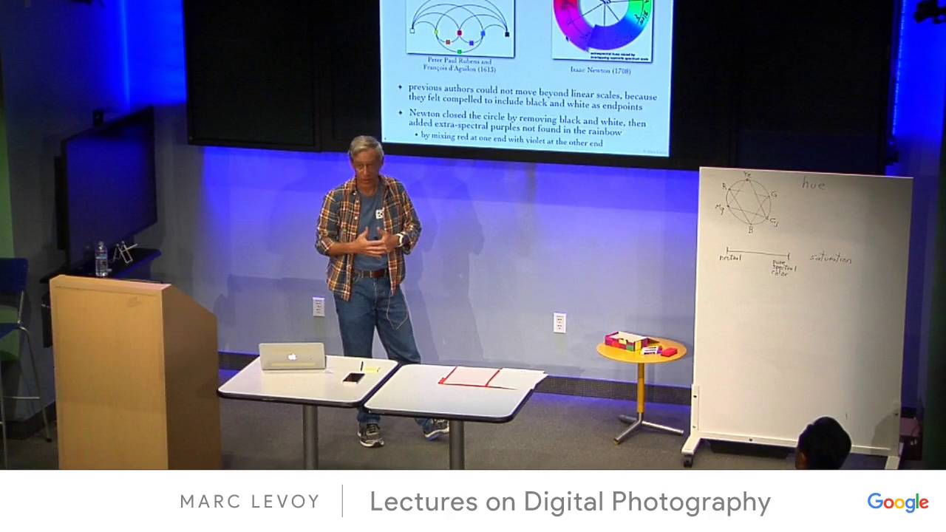
Marc Levoy - Lectures on Digital Photography - Lecture 13 (04May16).mp4

